Data Classification Frameworks: How Organizations Secure Sensitive Data
Timothy Victori
Arizona State University
IFT381: Information System Security
Professor John Lewis
10/5/2025

Table of Contents
- Page 1:
  - Cover Page
- Page 2:
  - Table of Contents
- Page 3:
  - Introduction
- Page 4:
  - Classifying Your Data
  - Figure 1
- Page 5:
  - Classifying Your Data (Continued)
  - External Storage Devices and Data Storage Mediums
  - Laws and Regulations
- Page 6:
  - Laws and Regulations (Continued)
  - Conclusion
- Page :
  - References
Introduction
In this paper we will talk about various data classification frameworks and how each one is used to protect sensitive company data. Data classification as defined by Microsoft is “ …a specialized term used in the fields of cybersecurity and information governance to describe the process of identifying, categorizing, and protecting content according to its sensitivity or impact level” (Microsoft, 2024). Using data classification to categorize your data into levels of impact can help keep data only accessible to who would require access in your organization. A data classification framework is typically split into 3-5 separate levels based on how sensitive the data is and how impactful would a leak of this sensitive data become. NIST is an organization run by the U.S. Department of Commerce and produce many standards commonly used in cyber security. We will be using NIST IR 8496 to discuss data classification frameworks in this document. This paper will go over the best practices and various frameworks for data classification in the current cyber security climate.

Classifying Your Data
In a production environment to protect your data from being used by parties you are not intending to give access to you must first determine what data is accessible to who. We start by setting up how we are going to classify data. Usually this is in order of risk (High risk, medium risk, low risk for example). You must also classify what your data is whether it be type of data (potentially personally identifiable information, private health information, internal only, etc.). According to NIST IR 8496 there are five primary functions that should be performed for data classification. These include defining the classification policy for your organization, identifying what assets need to be classified, choosing which data classification each asset belongs in, and monitoring the data in case of need of reclassification of the data due to its contents (Newhouse et al., 2023). When designing your framework keep in mind your organization’s purpose and need for keeping sensitive data from who it is needed to be kept from. Figure 1 below shows an example of a classification level and what should be specified in said classification. This ensures classifications are clear and concise.
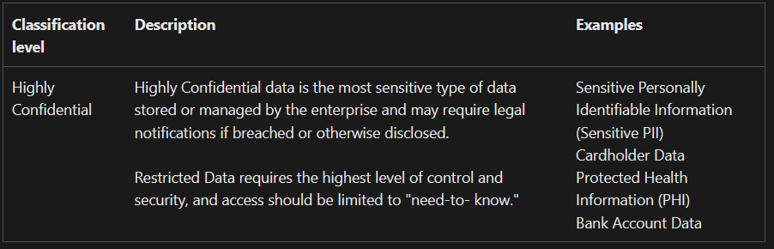
Figure 1: Example of Classification (Microsoft, 2024)
Each organization’s classification will be different based on the types of data they interact with on a regular basis. According to NIST you should always select data classifications

Classifying Your Data (Continued)
based on metadata in addition to the contents (Newhouse et al., 2023). Common classification types may include
- Public – freely available data no classification
  - Internal – for internal organization use only. Most employees will likely have access here. If they leak very unlikely this will harm the organization
    - Confidential – May cause harm to the organization if leaked higher punishments should be given if leaked and less personnel should have access to it.
      - Restricted – select personnel should have access to this data. Highly classified
(Sullivan, 2023).
External Storage Devices and Data Storage Mediums
Keeping track of what storage devices are accessing what data within your system is a must. In your classification framework in addition to mapping out each clearance level and its contents, you should map out what acceptable use policies should be for external storage devices. For example, you may have it so highly confidential data would not be acceptable to be stored on a personal device such as a flash drive while less sensitive information may be allowed to be transferred to those devices for ease of use. Providing training and awareness programs to staff can help insure your data classification framework is being properly followed (Rishat, 2024).
Laws and Regulations
Data classification is not only for your company’s security but also for compliance with local or international laws. Some laws such as HIPPA for Health data, and GDPR for EU

Laws and Regulations (Continued)
member country citizens’ private data may require adequate effort in protecting sensitive data as defined by the law. Each law lays out what type of data it protects and what it defines as adequate protection for that data and failure to follow laws and regulations may cause fines or reputational damage.
Conclusion
Data classification is an important measure to keep sensitive data away from individuals who may attempt to use the data in unauthorized manners. The classification of data allows easier distribution of data by the appropriate parties and lays out groundwork for what data should be given to what employees or how the data should be handled in a working environment. Laying out not only who gets what data but also how external devices should be handled in a system can allow you greater security and control over the data accumulated by your organization. Classification can also help with compliance with particular local or international laws in countries and states you may be conducting business in. Data classification should balance what is accessible based on both the ease of which data needs to be accessed in addition to the severity of the problems the organization may face in the face of a data breach.
References
Kale, V. (2015). Guide to cloud computing for business and technology managers: From distributed computing to cloudware applications, (1st ed.). Boca Raton, FL: CRC Press.
Microsoft (2024). Data classification & sensitivity label taxonomy - Microsoft Service Assurance. Learn.microsoft.com. https://learn.microsoft.com/en-us/compliance/assurance/assurance-data-classification-and-labels
Newhouse, W., Souppaya, M., Kent, J., Sandlin, K., & Scarfone, K. (2023, November). NIST IR 8496: Data Classification Concepts and Considerations for Improving Data Protection (NIST, Ed.) [Review of NIST IR 8496: Data Classification Concepts and Considerations for Improving Data Protection ]. https://nvlpubs.nist.gov/nistpubs/ir/2023/NIST.IR.8496.ipd.pdf
Rishat. (2024, May 24). Data Classification Framework. DataSunrise. https://www.datasunrise.com/knowledge-center/data-classification-framework/
Sullivan, M. (2023, December 8). Data classification in the context of privacy. Transcend Blog. https://transcend.io/blog/data-classification
‌

‌

‌

‌

